Path

Definition
# Source: AI Source: Provided by: [Data Path: Persons Table -> ID Column: 1, Name_En Column: Motasem Essam] -> From: [ChatGPT] on [7/25/2026]
A path in geometry is a continuous route or sequence of connected points through which an object, point, or curve moves from one location to another.
In a geometric context, a path describes how a point travels or is connected through space, rather than only describing the set of points that satisfy a condition.
$$\boxed{\text{Path}=\text{A continuous route from one point to another}}$$
For example, a point can move from $A$to $B$along a straight line, a circular arc, or a curved path.
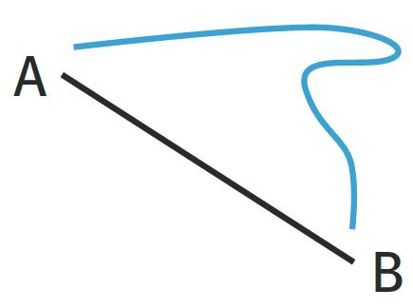
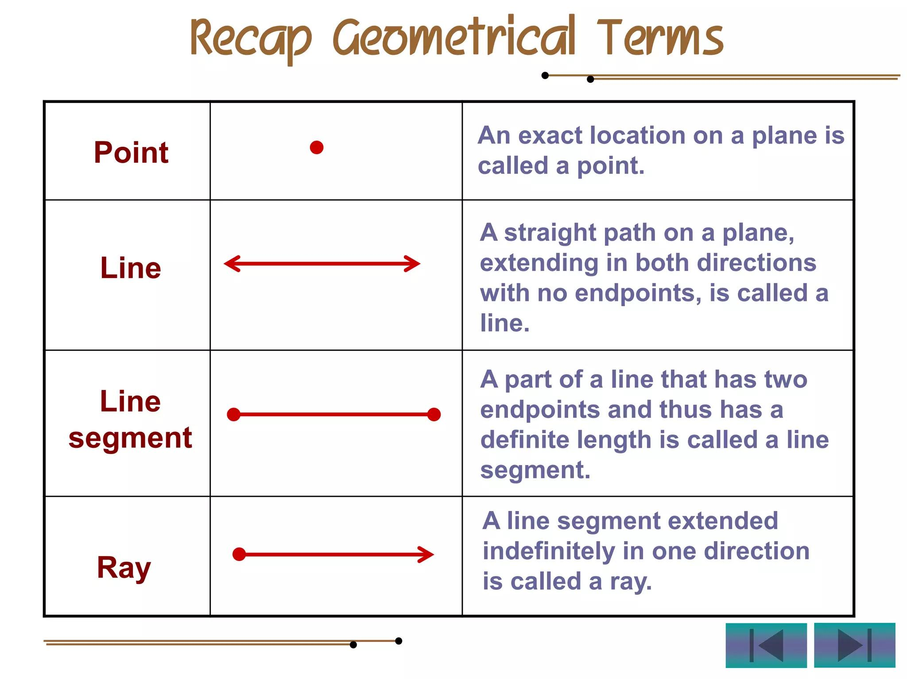
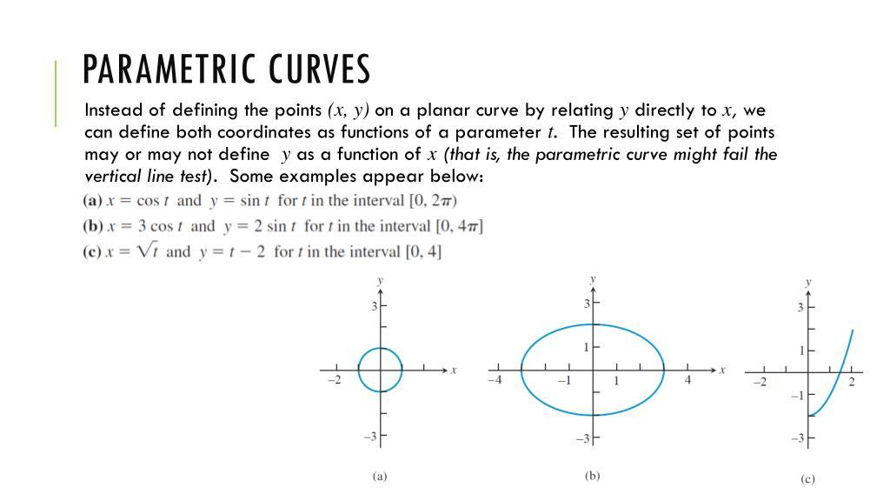
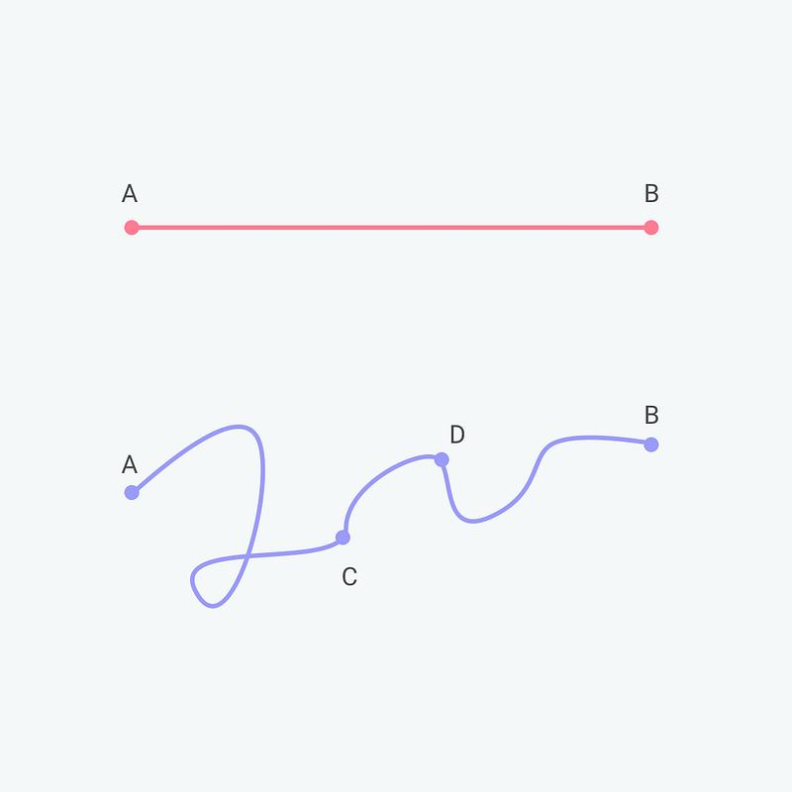
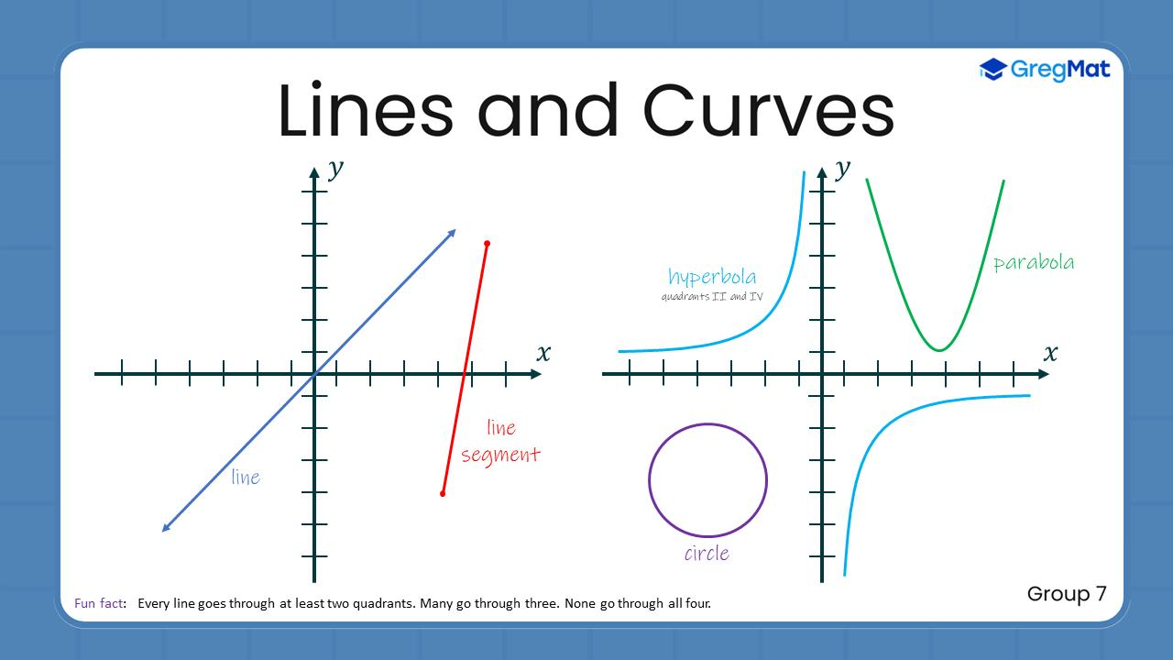

Simple Definition
# Source: AI Source: Provided by: [Data Path: Persons Table -> ID Column: 1, Name_En Column: Motasem Essam] -> From: [ChatGPT] on [7/25/2026]
A path is a connected route followed by a point or object.
Example:
If a point moves from $A$to $B$along a curved line:
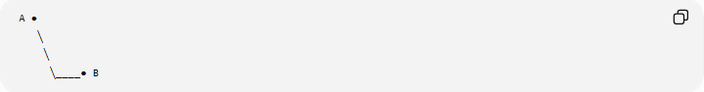
A ●
╲
╲
╲____● B
The curve between $A$and $B$is the path.

Fundamental Concept
# Source: AI Source: Provided by: [Data Path: Persons Table -> ID Column: 1, Name_En Column: Motasem Essam] -> From: [ChatGPT] on [7/25/2026]
A path focuses on movement or connection.
$$\boxed{\text{Starting Point}→\text{Intermediate Points}→\text{Ending Point}}$$
A path can be represented mathematically using a parametric equation:
$$P\left(t\right)=\left(x , \left(t\right)y\left(t\right)\right)$$
where $t$is a parameter describing the position of the point along the path.
For example:
$$P\left(t\right)=\left(t , t^{2}\right), 0≤t≤2$$
describes a portion of the parabola
$$y=x^{2}.$$

Main Types of Geometric Paths
# Source: AI Source: Provided by: [Data Path: Persons Table -> ID Column: 1, Name_En Column: Motasem Essam] -> From: [ChatGPT] on [7/25/2026]
A practical classification is:
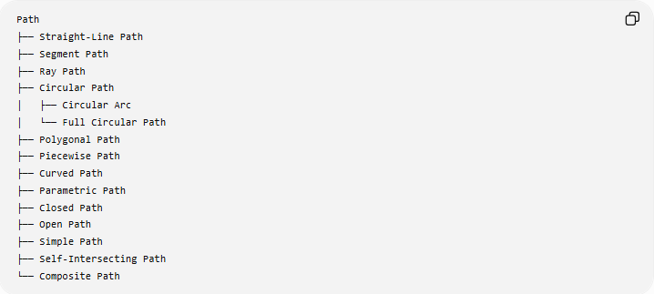
Path
├── Straight-Line Path
├── Segment Path
├── Ray Path
├── Circular Path
│ ├── Circular Arc
│ └── Full Circular Path
├── Polygonal Path
├── Piecewise Path
├── Curved Path
├── Parametric Path
├── Closed Path
├── Open Path
├── Simple Path
├── Self-Intersecting Path
└── Composite Path
These categories can overlap. For example, a closed path can also be a circular path.

Straight-Line Path

Definition
# Source: AI Source: Provided by: [Data Path: Persons Table -> ID Column: 1, Name_En Column: Motasem Essam] -> From: [ChatGPT] on [7/25/2026]
A straight-line path is a path that follows one straight line between its points.
If a point travels directly from $A$to $B$:
$$P\left(t\right)=A+t\left(B-A\right), 0≤t≤1$$

Example
# Source: AI Source: Provided by: [Data Path: Persons Table -> ID Column: 1, Name_En Column: Motasem Essam] -> From: [ChatGPT] on [7/25/2026]
Let
$$A=\left(1 , 2\right), B=\left(5 , 4\right).$$
Then
$$P\left(t\right)=\left(1 , 2\right)+t\left(4 , 2\right)$$
so
$$P\left(t\right)=\left(1 , +4t2+2t\right).$$
At $t=0$:
$$P\left(0\right)=A$$
and at $t=1$:
$$P\left(1\right)=B.$$

Segment Path

Definition
# Source: AI Source: Provided by: [Data Path: Persons Table -> ID Column: 1, Name_En Column: Motasem Essam] -> From: [ChatGPT] on [7/25/2026]
A segment path is a path restricted to the finite line segment connecting two points.
$$\boxed{\overset{‾}{AB}}$$

Example
# Source: AI Source: Provided by: [Data Path: Persons Table -> ID Column: 1, Name_En Column: Motasem Essam] -> From: [ChatGPT] on [7/25/2026]
A person walking directly from point $A$to point $B$along a straight road segment follows a segment path.
A ●────────────────● B
Unlike a complete line, the path has two endpoints.

Ray Path

Definition
# Source: AI Source: Provided by: [Data Path: Persons Table -> ID Column: 1, Name_En Column: Motasem Essam] -> From: [ChatGPT] on [7/25/2026]
A ray path begins at one endpoint and continues indefinitely in one direction.
$$\boxed{\vec{AB}}$$

Example
# Source: AI Source: Provided by: [Data Path: Persons Table -> ID Column: 1, Name_En Column: Motasem Essam] -> From: [ChatGPT] on [7/25/2026]
A ●────────────────────────────→
The path starts at $A$and continues through $B$.

Circular Path

Definition
# Source: AI Source: Provided by: [Data Path: Persons Table -> ID Column: 1, Name_En Column: Motasem Essam] -> From: [ChatGPT] on [7/25/2026]
A circular path follows the circumference of a circle.
For a circle centered at $O=\left(h , k\right)$with radius $r$:
$$P\left(t\right)=\left(h , +r\cos{t} k+r\sin{t}\right)$$

Example
# Source: AI Source: Provided by: [Data Path: Persons Table -> ID Column: 1, Name_En Column: Motasem Essam] -> From: [ChatGPT] on [7/25/2026]
For a circle centered at the origin:
$$P\left(t\right)=\left(5 , \cos{t}5\sin{t}\right)$$
describes a circular path of radius $5$.

Circular Arc Path
# Source: AI Source: Provided by: [Data Path: Persons Table -> ID Column: 1, Name_En Column: Motasem Essam] -> From: [ChatGPT] on [7/25/2026]
A circular arc path follows only part of a circle.
If
$$α≤t≤β,$$
then
$$P\left(t\right)=\left(h , +r\cos{t}k+r\sin{t}\right)$$
describes the corresponding arc.
Example
A point traveling from $A$to $B$around part of a circular track follows a circular arc path.

Polygonal Path

Definition
# Source: AI Source: Provided by: [Data Path: Persons Table -> ID Column: 1, Name_En Column: Motasem Essam] -> From: [ChatGPT] on [7/25/2026]
A polygonal path consists of a sequence of connected line segments.
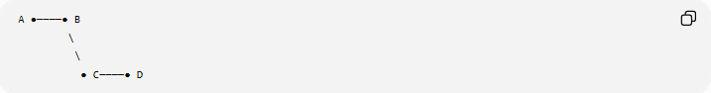
A ●────● B
\
\
● C────● D
The path is:
$$A→B→C→D$$

Example
# Source: AI Source: Provided by: [Data Path: Persons Table -> ID Column: 1, Name_En Column: Motasem Essam] -> From: [ChatGPT] on [7/25/2026]
A path through points
$$A\left(0 , 0\right),B\left(2 , 1\right),C\left(4 , 0\right),D\left(5 , 3\right)$$
consists of the segments
$$\overset{‾}{AB}, \overset{‾}{BC}, \overset{‾}{CD}.$$

Piecewise Path

Definition
# Source: AI Source: Provided by: [Data Path: Persons Table -> ID Column: 1, Name_En Column: Motasem Essam] -> From: [ChatGPT] on [7/25/2026]
A piecewise path is composed of different mathematical forms over different intervals.
For example, one part may be a line segment and another part may be a circular arc.
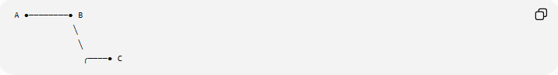
A ●────────● B
╲
╲
╭────● C
Mathematically:
$$P\left(t\right)=\left\{\begin{matrix}P_{1}\left(t\right), & a≤t≤b \\ P_{2}\left(t\right), & b<t≤c\end{matrix}\right.$$

Example
# Source: AI Source: Provided by: [Data Path: Persons Table -> ID Column: 1, Name_En Column: Motasem Essam] -> From: [ChatGPT] on [7/25/2026]
A route could consist of:
- a straight segment from $A$to $B$,
- a circular arc from $B$to $C$.
This is a piecewise path.

Curved Path

Definition
# Source: AI Source: Provided by: [Data Path: Persons Table -> ID Column: 1, Name_En Column: Motasem Essam] -> From: [ChatGPT] on [7/25/2026]
A curved path follows a continuously changing direction rather than remaining a straight line.
Examples include:
- parabola
- ellipse
- hyperbola
- spiral
- arbitrary smooth curve.

Example
# Source: AI Source: Provided by: [Data Path: Persons Table -> ID Column: 1, Name_En Column: Motasem Essam] -> From: [ChatGPT] on [7/25/2026]
A parabolic path can be represented by:
$$P\left(t\right)=\left(t , t^{2}\right).$$
The point changes direction continuously as $t$changes.

Parametric Path

Definition
# Source: AI Source: Provided by: [Data Path: Persons Table -> ID Column: 1, Name_En Column: Motasem Essam] -> From: [ChatGPT] on [7/25/2026]
A parametric path represents the coordinates of a moving point using a parameter.
$$\boxed{P\left(t\right)=\left(x , \left(t\right)y\left(t\right)\right)}$$
The parameter $t$often represents time or progression along the path.

Example
# Source: AI Source: Provided by: [Data Path: Persons Table -> ID Column: 1, Name_En Column: Motasem Essam] -> From: [ChatGPT] on [7/25/2026]
$$P\left(t\right)=\left(t , 2t+1\right), 0≤t≤5.$$
This describes a straight path.
Another example:
$$P\left(t\right)=\left(\cos{t} , \sin{t}\right)$$
describes a circular path.
Important Point
A parametric equation is a representation method, rather than a particular geometric shape. A line, circle, ellipse, or other curve can all be represented parametrically.

Open Path

Definition
# Source: AI Source: Provided by: [Data Path: Persons Table -> ID Column: 1, Name_En Column: Motasem Essam] -> From: [ChatGPT] on [7/25/2026]
An open path has different starting and ending points.
$$\boxed{A≠B}$$
when the path starts at $A$and ends at $B$.

Example
# Source: AI Source: Provided by: [Data Path: Persons Table -> ID Column: 1, Name_En Column: Motasem Essam] -> From: [ChatGPT] on [7/25/2026]
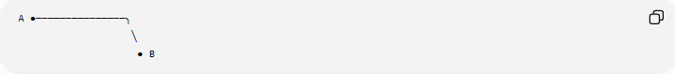
A ●───────────────╮
╲
● B
The path does not return to its starting point.

Closed Path

Definition
# Source: AI Source: Provided by: [Data Path: Persons Table -> ID Column: 1, Name_En Column: Motasem Essam] -> From: [ChatGPT] on [7/25/2026]
A closed path returns to its starting point.
If
$$P\left(a\right)=P\left(b\right),$$
then the path is closed over the interval $\left[a , b\right]$.

Examples
# Source: AI Source: Provided by: [Data Path: Persons Table -> ID Column: 1, Name_En Column: Motasem Essam] -> From: [ChatGPT] on [7/25/2026]
- circle
- ellipse
- triangle boundary
- rectangle boundary
- polygon boundary.
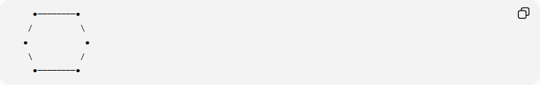
●────────●
/ \
● ●
\ /
●────────●
The path eventually returns to its starting point.

Simple Path

Definition
# Source: AI Source: Provided by: [Data Path: Persons Table -> ID Column: 1, Name_En Column: Motasem Essam] -> From: [ChatGPT] on [7/25/2026]
A simple path does not cross itself.
The path may curve or change direction, but it does not have self-intersections.

Example
# Source: AI Source: Provided by: [Data Path: Persons Table -> ID Column: 1, Name_En Column: Motasem Essam] -> From: [ChatGPT] on [7/25/2026]
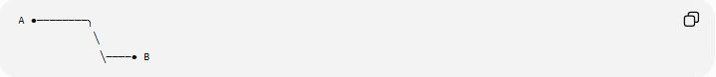
A ●────────╮
╲
╲────● B
There is no point where the path crosses itself.

Self-Intersecting Path

Definition
# Source: AI Source: Provided by: [Data Path: Persons Table -> ID Column: 1, Name_En Column: Motasem Essam] -> From: [ChatGPT] on [7/25/2026]
A self-intersecting path crosses itself at one or more points.

Example
# Source: AI Source: Provided by: [Data Path: Persons Table -> ID Column: 1, Name_En Column: Motasem Essam] -> From: [ChatGPT] on [7/25/2026]
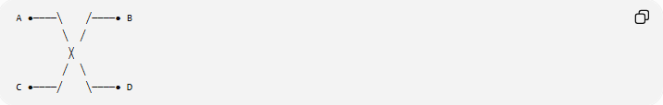
A ●────╲ ╱────● B
╲ ╱
╳
╱ ╲
C ●────╱ ╲────● D
The path intersects itself at the crossing point.
This is important when distinguishing simple paths from paths that contain self-intersections.

Composite Path

Definition
# Source: AI Source: Provided by: [Data Path: Persons Table -> ID Column: 1, Name_En Column: Motasem Essam] -> From: [ChatGPT] on [7/25/2026]
A composite path is formed by joining two or more different path sections.
For example:
$$\boxed{\text{Line Segment}+\text{Circular Arc}+\text{Line Segment}}$$

Example
# Source: AI Source: Provided by: [Data Path: Persons Table -> ID Column: 1, Name_En Column: Motasem Essam] -> From: [ChatGPT] on [7/25/2026]
A road might consist of:
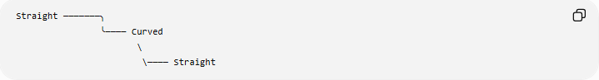
Straight ───────╮
╰──── Curved
\
\──── Straight
Each part has a different geometric form, but together they create one continuous path.

Path Length
# Source: AI Source: Provided by: [Data Path: Persons Table -> ID Column: 1, Name_En Column: Motasem Essam] -> From: [ChatGPT] on [7/25/2026]
The length of a path is the total distance traveled along it.
For a straight segment:
$$L=AB$$
For a circular arc:
$$L=rθ$$
when $θ$is measured in radians.
For a general parametric path
$$P\left(t\right)=\left(x , \left(t\right)y\left(t\right)\right),$$
the length from $t=a$to $t=b$is
$$\boxed{L=\int_{a}^{b}{\sqrt{{\left(\frac{dx}{dt}\right)}^{2}+{\left(\frac{dy}{dt}\right)}^{2}}} dt}$$
Example
For a circle of radius $5$, a quarter-circle has
$$θ=\frac{π}{2}.$$
Therefore:
$$L=5\left(\frac{π}{2}\right)=\frac{5π}{2}.$$

Path vs Locus
# Source: AI Source: Provided by: [Data Path: Persons Table -> ID Column: 1, Name_En Column: Motasem Essam] -> From: [ChatGPT] on [7/25/2026]
These concepts are closely related but emphasize different ideas.
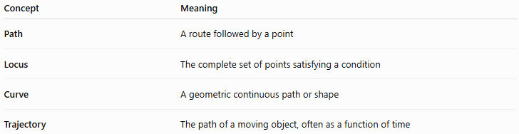
Concept | Meaning
Path | A route followed by a point
Locus | The complete set of points satisfying a condition
Curve | A geometric continuous path or shape
Trajectory | The path of a moving object, often as a function of time
Example
Suppose a point moves around a circle.
Its path is the route it follows:
$$P\left(t\right)=\left(r , \cos{t}r\sin{t}\right).$$
The locus is the set of all points satisfying:
$$x^{2}+y^{2}=r^{2}.$$
So:
$$\boxed{\text{Path emphasizes movement}}$$
while
$$\boxed{\text{Locus emphasizes the set of points}}$$

Path vs Curve
# Source: AI Source: Provided by: [Data Path: Persons Table -> ID Column: 1, Name_En Column: Motasem Essam] -> From: [ChatGPT] on [7/25/2026]
A curve describes the geometric object itself.
A path emphasizes a route, often with a starting point, ending point, or parameterization.
For example, the entire parabola
$$y=x^{2}$$
is a curve.
A point moving along only the portion
$$0≤x≤3$$
can be described as following a path on that curve.
Thus, a path can be a portion of a curve.

Path vs Trajectory
# Source: AI Source: Provided by: [Data Path: Persons Table -> ID Column: 1, Name_En Column: Motasem Essam] -> From: [ChatGPT] on [7/25/2026]
These terms are closely related.
- Path → geometric route.
- Trajectory → path traced by a moving object, commonly with time as the parameter.
For example:
$$P\left(t\right)=\left(t , t^{2}\right)$$
can represent the trajectory of a moving point.
If $t$represents time, then the path and trajectory describe both the geometry and the motion.

Classification Summary
# Source: AI Source: Provided by: [Data Path: Persons Table -> ID Column: 1, Name_En Column: Motasem Essam] -> From: [ChatGPT] on [7/25/2026]
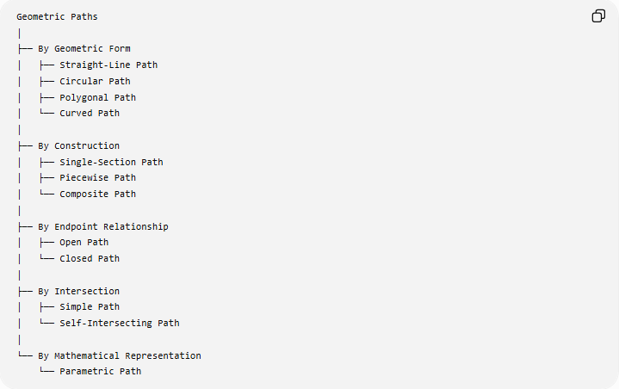
Geometric Paths
│
├── By Geometric Form
│ ├── Straight-Line Path
│ ├── Circular Path
│ ├── Polygonal Path
│ └── Curved Path
│
├── By Construction
│ ├── Single-Section Path
│ ├── Piecewise Path
│ └── Composite Path
│
├── By Endpoint Relationship
│ ├── Open Path
│ └── Closed Path
│
├── By Intersection
│ ├── Simple Path
│ └── Self-Intersecting Path
│
└── By Mathematical Representation
└── Parametric Path
This is a practical classification, not a single universally standardized taxonomy. Some categories describe the geometry, while others describe the path's topology or representation.

Important Distinctions
# Source: AI Source: Provided by: [Data Path: Persons Table -> ID Column: 1, Name_En Column: Motasem Essam] -> From: [ChatGPT] on [7/25/2026]
Path vs Segment
A segment is specifically a finite straight portion of a line.
A path can be straight or curved.
Path vs Line
A line extends infinitely in both directions:
$$\overset{↔}{AB}$$
A path normally refers to a particular route, often with a specified portion and direction.
Path vs Locus
$$\boxed{\text{Path}=\text{route}} \\ \boxed{\text{Locus}=\text{set of points}}$$
Path vs Region
A path is generally one-dimensional, whereas a region contains an area of points and is two-dimensional.

Key Properties of Paths
# Source: AI Source: Provided by: [Data Path: Persons Table -> ID Column: 1, Name_En Column: Motasem Essam] -> From: [ChatGPT] on [7/25/2026]
Depending on the type of path, important properties include:
- Starting point
- Ending point
- Direction
- Length
- Shape
- Continuity
- Curvature
- Self-intersections
- Whether it is open or closed
- Parametric representation
For a path
$$P\left(t\right), a≤t≤b,$$
the starting and ending points are:
$$P\left(a\right), P\left(b\right).$$

Key Points
# Source: AI Source: Provided by: [Data Path: Persons Table -> ID Column: 1, Name_En Column: Motasem Essam] -> From: [ChatGPT] on [7/25/2026]
- A path is a continuous route followed by a point or used to connect locations.
- A path can be straight, curved, circular, polygonal, or composite.
- A path can be open or closed.
- A path can be simple or self-intersecting.
- A path can be represented parametrically:
$$P\left(t\right)=\left(x , \left(t\right)y\left(t\right)\right).$$
- The length of a general parametric path can be calculated using:
$$L=\int_{a}^{b}{\sqrt{{\left(x^{'}\left(t\right)\right)}^{2}+{\left(y^{'}\left(t\right)\right)}^{2}}} dt.$$
- A locus describes the complete set of points satisfying a condition, while a path emphasizes the route or progression through points.
- A trajectory is commonly the path of a moving object, especially when parameterized by time.
- A path may be only a portion of a larger curve.

Conclusion
# Source: AI Source: Provided by: [Data Path: Persons Table -> ID Column: 1, Name_En Column: Motasem Essam] -> From: [ChatGPT] on [7/25/2026]
A path is a geometric route connecting or traversed between points. It may be a straight segment, circular arc, polygonal route, smooth curve, or combination of several sections. Paths are particularly useful for describing movement, connection, distance traveled, and continuous geometric routes, while related concepts such as curves and loci emphasize the underlying geometric set or shape.

